Triple Time Stamping
By Michele Jutrisa - www.butterflysandbows.com

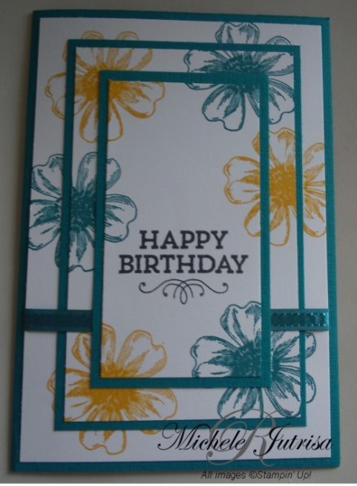
This technique seems to be around for some time and there are many examples of it on the internet. But there seems to be one standard or basic design which we will be doing today.

Equipment
1 sheets of Whisper White or Very Vanilla Cardstock
1 sheet coloured cardstock- Island Indigo
Stamp Set- Flower Shop
Stamp Set- Hay You
Ink- Memento Black
Crushed Curry
Island Indigo
Snail Adhesive
Paper trimmer
Ribbon

- Cut cardstock to measurements below

Whisper White or Very Vanilla |  |  | Coloured Cardstock
 | Metric | Imperial |  | Metric | Imperial
1 | 5 x 9.5 cm | 2 x 3-3/4” | A | 5.7 x 10.2 cm | 2-1/4 x 4”
2 | 7.5 x 12 cm | 2-15/16 x 4-11/16” | B | 8 x 12.5 cm | 3-3/16 x 5”
3 | 9.8 x 14.3 cm | 3-7/8 x 5-5/8” | CB* | 21 x 14.8 cm | 8-1/4 x 5-7/8”
4 | 9.8 x 14.3 cm | 3-7/8 x 5-5/8”
*CB-Card Base, score at 10.5 cm / 4-1/8”

- Layer the white card stock on top of each other, putting a small amount of adhesive on the back of white cardstock pieces 2 & 3.
HINT: We don’t want the layers to stick permanently so tap the adhesive on your clothes to take of the stickiness.

1
2
3

- Random stamp on top of the 3 layers. Start with stamping the sentiment first. Then randomly stamp around stamping over the layers. There will be white gaps between the layers, don’t worry about this. These will be covered up with the matting.

- Stamp Card 4 in the right hand corner, this will be adhered to the inside of the card.

- Separate the 3 layers by gently pulling them apart. Mount these onto the matting. 3 will be adhered to C, 2 –B
HINT: Keep all the pieces in the same direction so that they can all go back together again.

- Assemble your Card. We will be wrapping some ribbon around the 2,B & 3 layers before adhering together.

